**Chapter 6 – Team Project: Normalizing the Relational Model for the Team Project and Creating a Normalized Oracle Database.**

*Submit this document with your answers, DDL statements, and SQL*Plus screenshots. Do not change the order of the questions. Do not remove anything from this document. Do not create a new document. Provide your answers inline. Failure to submit this document will result in no credit.*

*Before submitting, edit the file name by including your team number as a prefix.*

*Ex: Team Number - Chapter 6 Team Project.docx*

*Follow the same format for any additional files that you submit.*

*Note: Do not submit zip files or pdfs.*

Read the sample project steps for this chapter and use it as a model in carrying out the steps for your team project. For the team project, do the following:

**Step 6.1 - Begin with the relational schema that you developed at the end of Chapter 4 for the team project.** For each table on the list, identify functional dependencies and normalize the relation to BCNF. Then decide whether the resulting tables should be implemented in that form. If not, explain why.

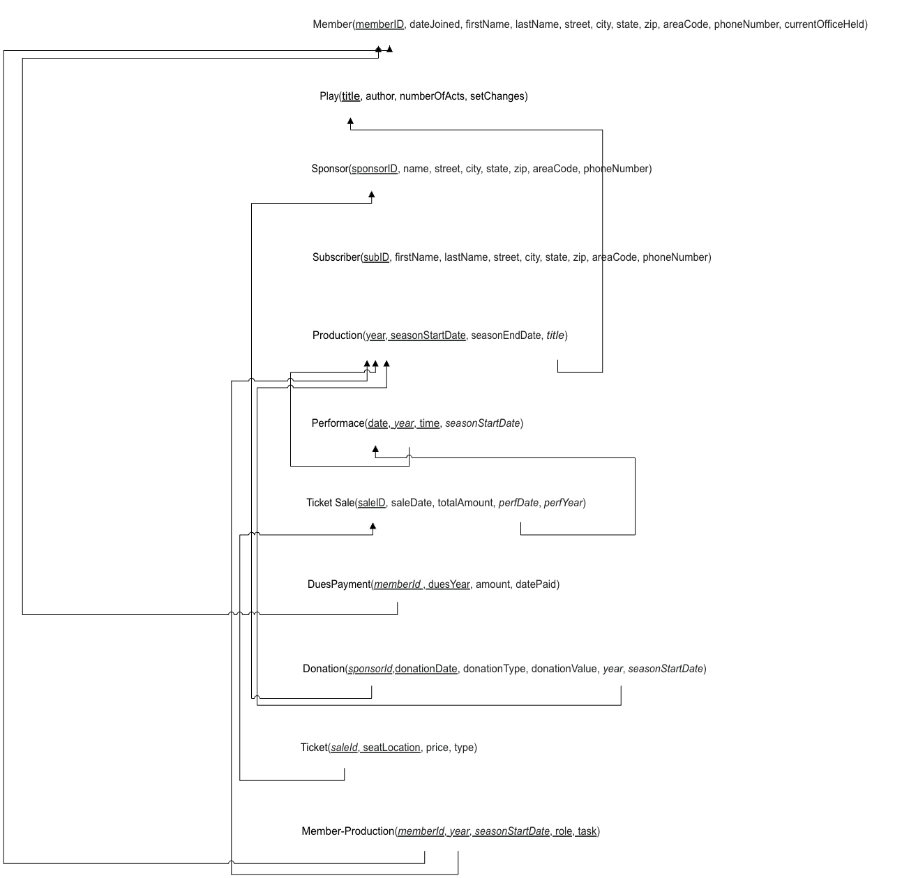

**TABLE member:**

Functional dependencies:

1. memberID → firstName, lastName, dateJoined, street, city, state, zip, areaCode, phoneNumber, currentOfficeHeld
2. zip → city, state

In BCNF? No.

Solution: Create separate table for zip code.

**TABLE play:**

Functional dependencies:

1. title → author, numberOfActs, setChanges

in BCNF? Yes – keep table as is.

**TABLE sponsor:**

Functional dependencies:

1. sponsorID → name, street, city, state, zip, areaCode, phoneNumber
2. zip → city, state

In BCNF? No.

Solution: Move zip, city, and state to zip code table.

**TABLE subscriber:**

Functional dependencies:

1. subID → firstName, lastName, street, city, state, zip, areaCode, phoneNumber
2. zip → city, state

In BCNF? No.

Solution: Move zip, city, and state to zip code table.

**TABLE production:**

Functional dependencies:

1. {year, seasonStartDate, title} → seasonEndDate

In BCNF? Yes – keep table as is.

**TABLE performance:**

Functional dependencies:

1. {date, year, time, seasonStartDate} → production
2. {year, seasonStartDate} → production

In BCNF? No - {year, seasonStartDate} **should be a separate reference to** Production.

Solution**:** Replace year, seasonStartDate with productionID.

**TABLE ticketsale:**

Functional dependencies:

1. saleID → saleDate, totalAmount, perfDate, perfYear
2. {perfDate, perfYear} → Performance

In BCNF? No - {perfDate, perfYear} → Performance **creates redundancy of performace info**

Solution: Replace perfDate, perfYear with perfid.

**TABLE duespayment:**

Functional dependencies: {memberID, duesYear} → amount, datePaid

In BCNF? Yes – keep table as is.

**TABLE donation:**

Functional dependencies:

1. {sponsorID, donationDate} → donationType, donationValue, year, seasonStartDate
2. {year, seasonStartDate} → Production

In BCNF? No – redundancy in {year, seasonStartDate} → Production.

Solution: Replace year, seasonStartDate with productionID.

**TABLE ticket:**

Functional dependencies:

1. {saleID, seatLocation} → price, type

In BCNF? No - {saleID, seatLocation} should be linked to Performance instead of Ticketsale.

Solution: Replace saleID with perfid.

**TABLE member-production:**

Functional dependencies:

1. {memberId, year, seasonStartDate} → role, task
2. {year, seasonStartDate} → productionID

In BCNF? No - A production is uniquely identified by productionID, not year and seasonStartDate

Solution: Replace year, seasonStartDate with productionID

**Step 6.2 – Review and update the data dictionary (as needed).**

Review the data dictionary that was created in the Chapter 5 Assignment. Update the data dictionary (as needed). If there are no updates, then relist your Chapter 5 data dictionary.

actorRole: The role that the actor played in a play performance.

admissionTicket: The play ticket given to a patron once after they’ve purchased it.

*audtionID- id number for the person auditioning

auditionType: The type of role a member is auditioning for – either cast or crew.

auditioningMemberFirstName: The first name of the member auditioning for the next play.

auditioningMemberLastName: The last name of the member auditioning for the next play.

cast: The group of members that act in a play performance.

contractorFees: The money spent by the group on hiring contractors.

crew: The group of members that contribute on the production team of a play performance.

*desiredRoles: The roles that a member wishes to audition for in the upcoming play.

equipmentRentalFees: The money spent by the group on equipment rental.

expenditures: The money spent by the group.

income: The money received by the group.

memberDues: The amount of money a member owes to be a part of the group. Cost is $50/year.

memberEmail: The email address of a member.

memberFirstName: The first name of a member.

memberLastName: The last name of a member.

memberPaid: Whether or not the member has paid their dues. Options include yes or no.

newMemberAddressLine: The street and apartment number (if applicable) where the new member currently lives.

newMemberCity: The city where the new member currently lives.

newMemberFirstName: The first name of a new member.

newMemberLastName: The last name of a new member.

newMemberPhoneNumber: The phone number of the new member, including the area code.

newMemberState: The state where the new member currently lives.

newMemberYearsofActingExperience: The number of years of acting experience a new member has.

newMemberZipCode: The zipcode of where the new member currently lives.

patronAddressLine: The street and apartment number (if applicable) where the patron currently lives.

patronCity: The city where the patron currently lives.

patronFirstName: The first name of the patron.

patronLastName: The last name of the patron.

patronPreviousPlay: The name of a play that a patron has previously attended.

patronState: The state where the patron currently lives.

patronZipcode: The zipcode where the patron currently lives.

playAuthor: The author of a play.

playDate: The date the play is performed on.

playSeason: The season when the play performs. The options are spring and fall.

playTime: The time a play starts.

playTitle: The title of a play.

playType: The type of play. Examples of valid values include but are not limited to comedy, drama, musical.

playYear: The year when the play performs.

previousRoles: The roles of the two previous plays that a member acted in, if applicable.

productionRole: The role a member contributed to in the production of the play.

*purchaseDate: The date in which the admission ticket purchased

reportEndingDate: The date chosen for the very end of the given report.

reportStartingDate: The date chosen for the very start of the given report.

seatLocationPreference: The location of seats in the auditorium a subscriber prefers to sit in.

seatNumber: The number and letter of the seat assigned to a patron.

sponsorCorporationName: The name of the corporation that sponsored the group.

sponsorFirstName: The first name of a sponsor.

sponsorLastName: The last name of a sponsor.

subsciberAddressLine: The street and apartment number (if applicable) where the subscriber currently lives.

subsciberFirstName: The first name of the subscriber.

subscriberCity: The city where the subscriber currently lives.

subscriberLastName: The last name of the subscriber.

subscriberPhoneNumber: The phone number including the area code of the subscriber.

subscriberState: The state where the subscriber currently lives.

subscriberZipcode: The zipcode where the subscriber currently lives.

ticketNumber: The number of the ticket to the play that was printed on it.

ticketPrice: The price of a ticket.

ticketSales: The money received by the group from selling tickets to the plays.

totalActs: The total number of acts in a play.

totalAuditoriumRentalFee: The total amount of money spent on renting an auditorium in a given report period.

totalContractorFee: The total amount of money spent on hiring contractors in a given report period.

totalEquipmentRentalFee: The total amount of money spent on renting equipment in a given report period.

totalExpenditures: The total amount of money spent by the group in a given report period.

totalIncome: The total amount of money received by the group in a given report period.

totalMemberDues: The total amount of money received from member dues in a given report period.

totalReservedSeats: The total number of seats in the auditorium a subscriber wishes to reserve for the play.

totalSponsorDonations: The total amount of money received from sponsors in a given report period.

**Step 6.3 – Review and update the list of assumptions (as needed).**

Review the list of assumptions that was created in the Chapter 5 Assignment. Update the list of assumptions (as needed). If there are no updates, then relist your Chapter 5 list of assumptions.

1. The database for the number of actors and names of each is ever changing depending on who remains in the organization.

2. The number of plays each year is a fixed number

3. Funding for the play is a huge part as it needs to advertise to fill seats

4. Tickets can be held in advance due to the subscription process or can be bought as close as the day of the show.

5. Members hold different roles besides acting and are not classified as “professionals”

6. Subscribers will be held accountable for dues each year(50$/yr)

7. The Balance sheet maintained by the treasurer is essential in identifying the financial situation of the organization and how funds can be allocated

8. If not reserved a single person can buy as many tickets as they please

9. Not all members are involved in productions each year

10. A member might not perform in every play.

11. A patron might not return for the next year to watch the play.

12. Tickets for each play might not sell out, and there will be empty seats

13. Payment for ticket sales will be paid immediately

14. Payment for tickets may be made by cash, credit card, or check.

15. Patrons may have moved houses and thus not received an advertisement that would encourage them to purchase a ticket.

16. A ticket cannot be refunded.

17. Patrons might only prefer to attend a play regarding whether or not they have interest in the play title.

18. A sponsor may also be a patron.

19. The balance sheet, if done right, will always have more income than expenditures.

20. No two tickets are the same.

21. Members are likely beginner and intermediate actors.

22. Each play needs one scheduled date

23. A sponsor can be an individual or patron

24. Each play has a unique title

25.There is one treasurer

26.One play listing for Show Program

27. New member info in Member Due Report

**Step 6.4 - For each table, write out the table name and the attribute names, data types, and data lengths and all constraints, using the conventions of the Oracle Database that you will use for implementation of a normalized database for the team project.**

CREATE TABLE ZipCode

zip CHAR(5) PRIMARY KEY

city VARCHAR2(50)

state CHAR(2)

CREATE TABLE Member

memberID VARCHAR2(6) PRIMARY KEY

dateJoined DATE

firstName VARCHAR2(20) NOT NULL

lastName VARCHAR2(20) NOT NULL

street VARCHAR2(50)

zip CHAR(5) FOREIGN KEY

areaCode CHAR(3)

phoneNumber CHAR(7)

CREATE TABLE Play

title VARCHAR2(40) PRIMARY KEY

author VARCHAR2(30)

numberOfActs NUMBER(10)

setChanges NUMBER(10)

CREATE TABLE Sponsor

sponsorID VARCHAR2(6) PRIMARY KEY

name VARCHAR2(20)

street VARCHAR2(50)

zip CHAR(5) FOREIGN KEY

areaCode CHAR(3)

phoneNumber CHAR(7)

CREATE TABLE Subscriber

subscriberID VARCHAR2(6) PRIMARY KEY

firstName VARCHAR2(15) NOT NULL

lastName VARCHAR2(20) NOT NULL

street VARCHAR2(50)

zip CHAR(5) FOREIGN KEY

areaCode CHAR(3)

phoneNumber CHAR(7)

CREATE TABLE Production

productionID NUMBER PRIMARY KEY

year NUMBER(4)

seasonStartDate DATE

seasonEndDate DATE

title VARCHAR2(40) FOREIGN KEY

CREATE TABLE Performance

performanceID NUMBER PRIMARY KEY

productionID NUMBER FOREIGN KEY

perfDate DATE

perfTime DATE

CREATE TABLE TicketSale

saleID VARCHAR2(6) PRIMARY KEY

saleDate DATE

totalAmount NUMBER(6,2)

performanceID NUMBER FOREIGN KEY

CREATE TABLE DuesPayment

memberID VARCHAR2(6) FOREIGN KEY

duesYear NUMBER(4)

amount NUMBER(6,2)

datePaid DATE

CREATE TABLE Donation

sponsorID VARCHAR2(6) FOREIGN KEY

donationDate DATE

donationType VARCHAR2(15)

donationValue NUMBER(6,2)

productionID NUMBER FOREIGN KEY

CREATE TABLE Ticket

ticketID NUMBER PRIMARY KEY

perfID NUMBER FOREIGN KEY

seatLocation VARCHAR2(2) UNIQUE

price NUMBER(6,2)

type VARCHAR2(10)

CREATE TABLE Member_Production

memberID VARCHAR2(6) PRIMARY KEY FOREIGN KEY

productionID NUMBER PRIMARY KEY FOREIGN KEY

role VARCHAR2(15)

task VARCHAR2(20)

**Step 6.5 – Step 6.8 - Creating a normalized database for Team Project.**

For each step:

- Use your Team’s Oracle User ID to run the SQL statements in the database. (Do not use SYS or SYSTEM).

- Write out the SQL statements that will be executed in the database (in addition to showing the SQL Statements in the screenshot).

- Execute the SQL statements in the database and provide a single, continuous screenshot that demonstrates the results without interruptions. The screenshot should also include the current user ID, the current system date, the execution of the SQL statements in the database, and the results of the SQL statements. To display the current user and current date, run the following statement before running each SQL statement:

SQL> select user||' '||to_char(sysdate, 'DD-MON-YYYY HH24:MI:SS') from dual;

Note: Omitting the required information in any step may result in reduced points or no credit for that step.

**Step 6.5 - Design SQL statements to create all objects (tables, constraints, indexes) needed to implement the design. Then execute the SQL statements in the database.**

DROP TABLE Ticket CASCADE CONSTRAINTS;

DROP TABLE TicketSale CASCADE CONSTRAINTS;

DROP TABLE Performance CASCADE CONSTRAINTS;

DROP TABLE Production CASCADE CONSTRAINTS;

DROP TABLE Donation CASCADE CONSTRAINTS;

DROP TABLE DuesPayment CASCADE CONSTRAINTS;

DROP TABLE Member_Production CASCADE CONSTRAINTS;

DROP TABLE Member CASCADE CONSTRAINTS;

DROP TABLE Sponsor CASCADE CONSTRAINTS;

DROP TABLE Subscriber CASCADE CONSTRAINTS;

DROP TABLE PLAY CASCADE CONSTRAINTS;

CREATE TABLE ZipCode (

zip CHAR(5) PRIMARY KEY,

city VARCHAR2(50),

state CHAR(2)

);

CREATE TABLE Member (

memberID VARCHAR2(6) PRIMARY KEY,

dateJoined DATE,

firstName VARCHAR2(20) NOT NULL,

lastName VARCHAR2(20) NOT NULL,

street VARCHAR2(50),

zip CHAR(5),

areaCode CHAR(3),

phoneNumber CHAR(7),

currentOfficeHeld VARCHAR2(20),

CONSTRAINT fk_member_zip FOREIGN KEY (zip) REFERENCES ZipCode(zip)

);

CREATE TABLE Play (

title VARCHAR2(40) PRIMARY KEY,

author VARCHAR2(30),

numberOfActs NUMBER(10),

setChanges NUMBER(10),

CONSTRAINT chk_acts CHECK (numberOfActs >= 1),

CONSTRAINT chk_setChanges CHECK (setChanges >= 0)

);

CREATE TABLE Sponsor (

sponsorID VARCHAR2(6) PRIMARY KEY,

name VARCHAR2(20),

street VARCHAR2(50),

zip CHAR(5),

areaCode CHAR(3),

phoneNumber CHAR(7),

CONSTRAINT fk_sponsor_zip FOREIGN KEY (zip) REFERENCES ZipCode(zip)

);

CREATE TABLE Subscriber (

subscriberID VARCHAR2(6) PRIMARY KEY,

firstName VARCHAR2(15) NOT NULL,

lastName VARCHAR2(20) NOT NULL,

street VARCHAR2(50),

zip CHAR(5),

areaCode CHAR(3),

phoneNumber CHAR(7),

CONSTRAINT fk_subscriber_zip FOREIGN KEY (zip) REFERENCES ZipCode(zip)

);

CREATE TABLE Production (

productionID NUMBER PRIMARY KEY,

year NUMBER(4),

seasonStartDate DATE,

seasonEndDate DATE,

title VARCHAR2(40),

CONSTRAINT fk_production_play FOREIGN KEY (title) REFERENCES Play(title),

CONSTRAINT chk_production_dates CHECK (seasonStartDate < seasonEndDate)

);

CREATE TABLE Performance (

performanceID NUMBER PRIMARY KEY,

productionID NUMBER,

perfDate DATE,

perfTime DATE,

CONSTRAINT fk_performance_production FOREIGN KEY (productionID) REFERENCES Production(productionID),

CONSTRAINT chk_performance_date CHECK (perfDate >= seasonStartDate)

);

CREATE TABLE TicketSale (

saleID VARCHAR2(6) PRIMARY KEY,

saleDate DATE,

totalAmount NUMBER(6,2),

performanceID NUMBER,

CONSTRAINT fk_ticketsale_performance FOREIGN KEY (performanceID) REFERENCES Performance(performanceID),

CONSTRAINT chk_totalAmount CHECK (totalAmount >= 0)

);

CREATE TABLE DuesPayment (

memberID VARCHAR2(6),

duesYear NUMBER(4),

amount NUMBER(6,2),

datePaid DATE,

PRIMARY KEY (memberID, duesYear),

CONSTRAINT fk_duespayment_member FOREIGN KEY (memberID) REFERENCES Member(memberID),

CONSTRAINT chk_dues_amount CHECK (amount >= 0)

);

CREATE TABLE Donation (

sponsorID VARCHAR2(6),

donationDate DATE,

donationType VARCHAR2(15),

donationValue NUMBER(6,2),

productionID NUMBER,

PRIMARY KEY (sponsorID, donationDate),

CONSTRAINT fk_donation_sponsor FOREIGN KEY (sponsorID) REFERENCES Sponsor(sponsorID),

CONSTRAINT fk_donation_production FOREIGN KEY (productionID) REFERENCES Production(productionID),

CONSTRAINT chk_donation_value CHECK (donationValue >= 0)

);

CREATE TABLE Ticket (

ticketID NUMBER PRIMARY KEY,

perfID NUMBER,

seatLocation VARCHAR2(2) UNIQUE,

price NUMBER(6,2),

type VARCHAR2(10),

CONSTRAINT fk_ticket_performance FOREIGN KEY (perfID) REFERENCES Performance(performanceID),

CONSTRAINT chk_ticket_price CHECK (price >= 0)

);

CREATE TABLE Member_Production (

memberID VARCHAR2(6),

productionID NUMBER,

role VARCHAR2(15),

task VARCHAR2(20),

PRIMARY KEY (memberID, productionID),

CONSTRAINT fk_member_production_member FOREIGN KEY (memberID) REFERENCES Member(memberID),

CONSTRAINT fk_member_production_production FOREIGN KEY (productionID) REFERENCES Production(productionID)

);

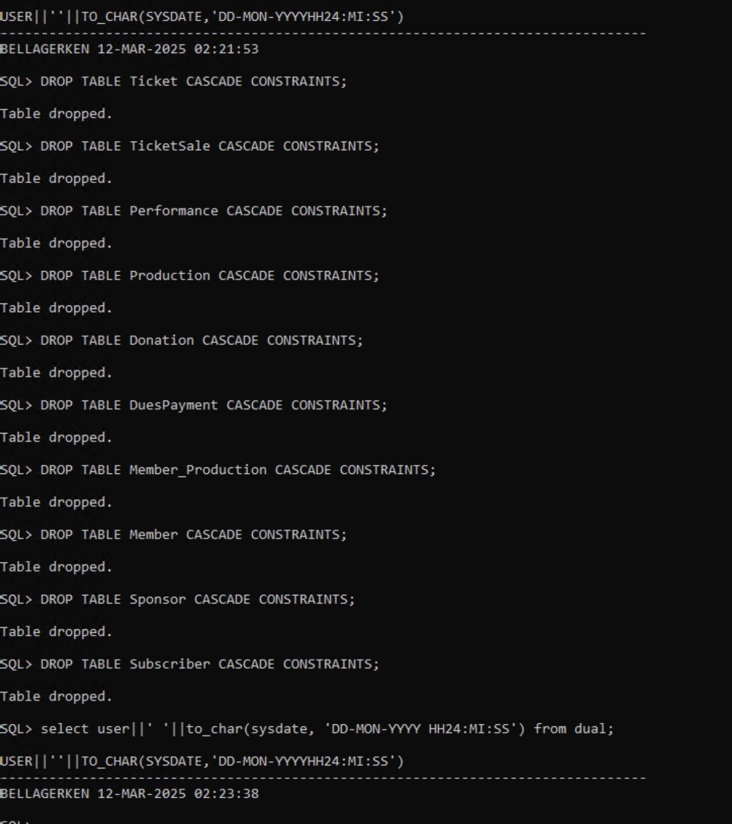

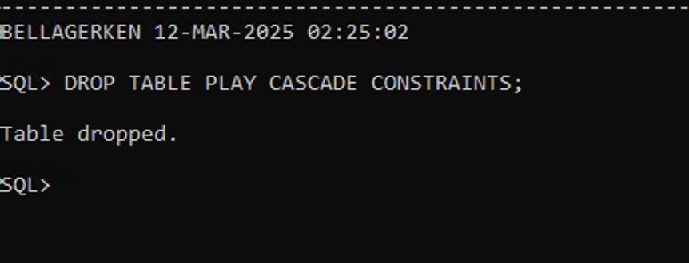

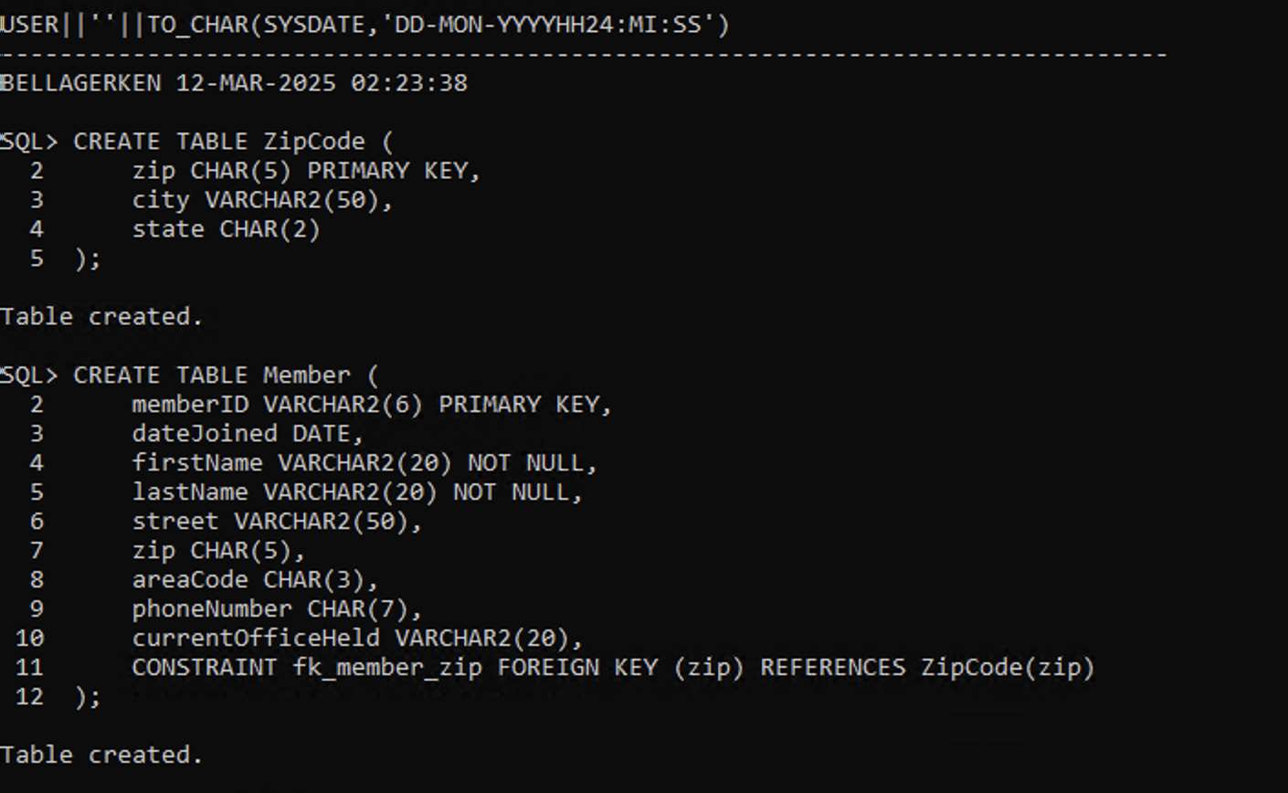

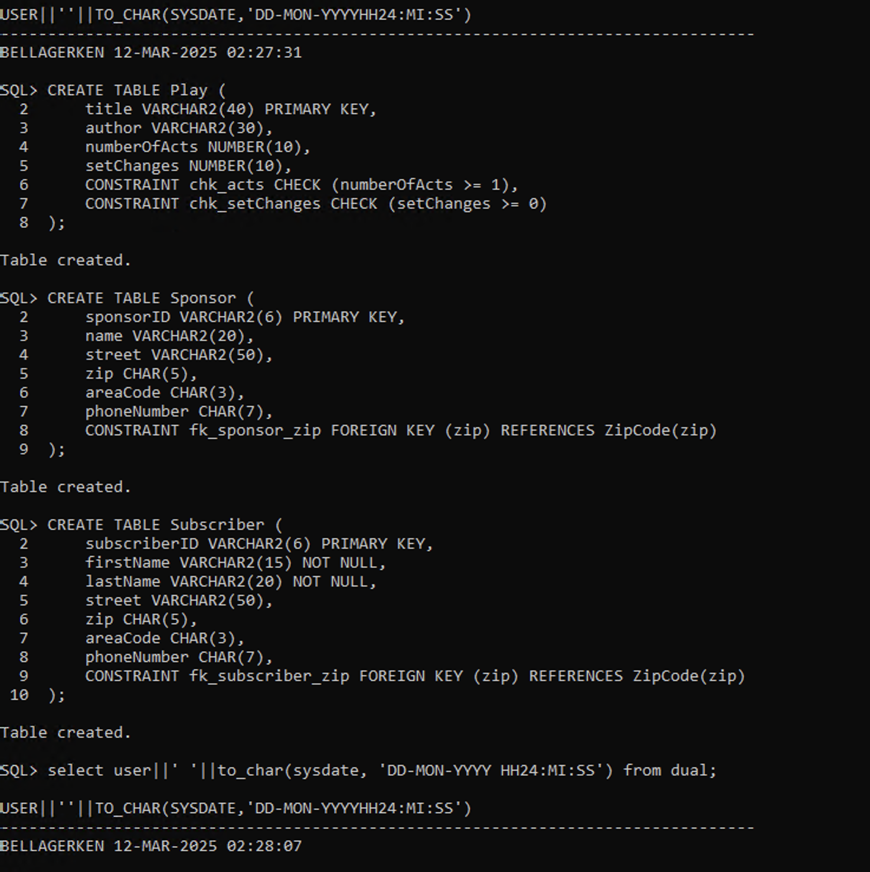

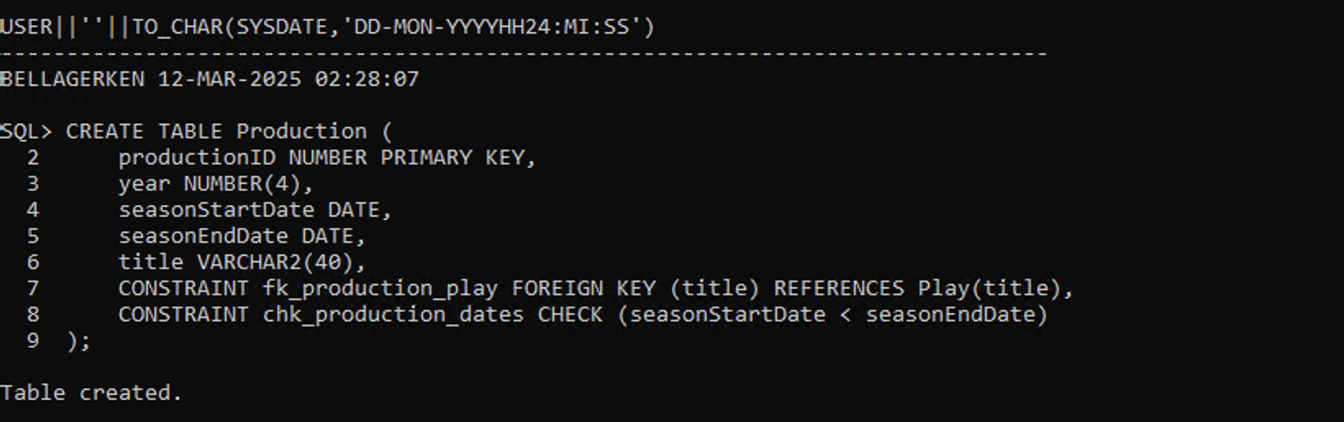

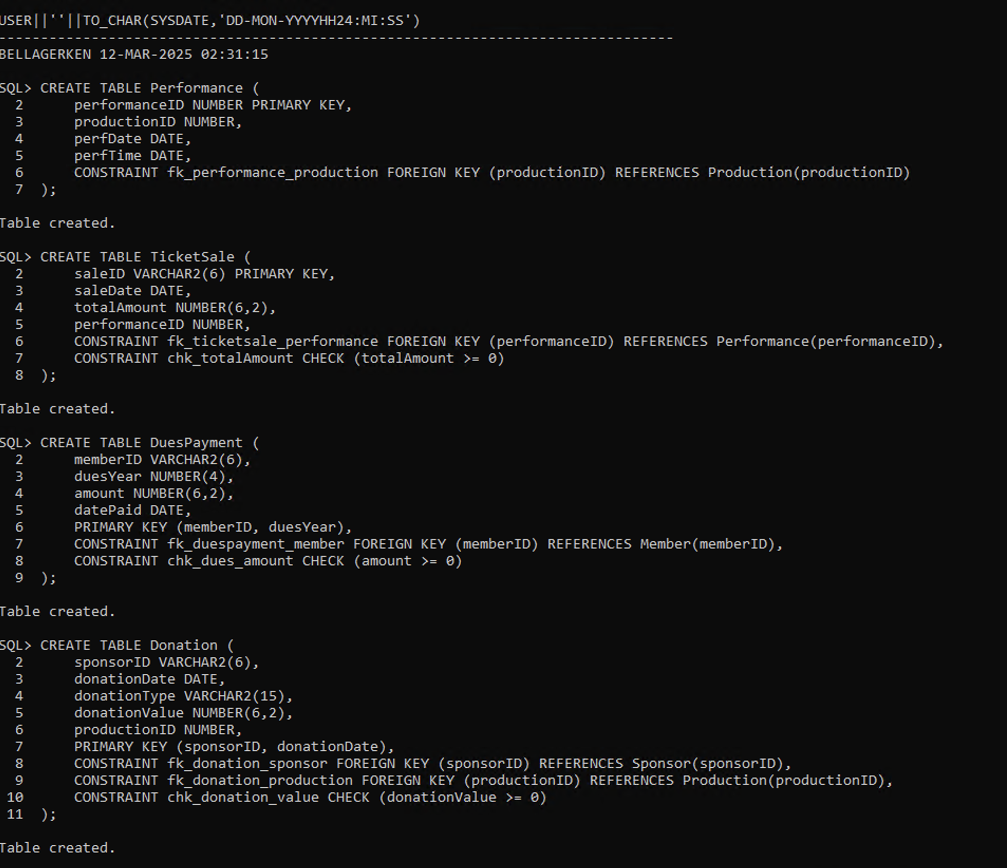

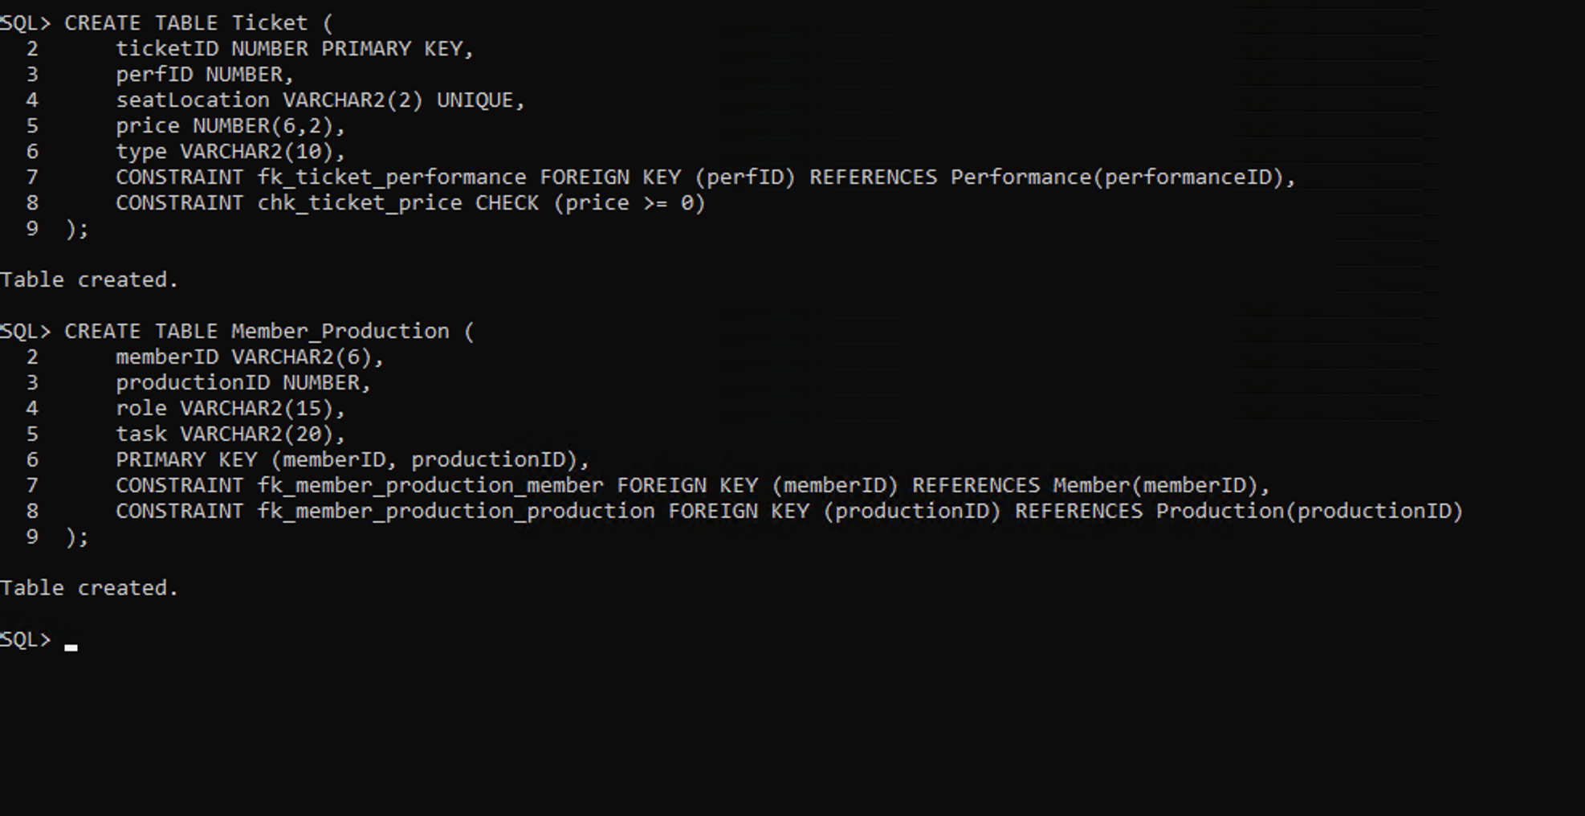

**6.6 - Design SQL statements to insert at least five records in each table, preserving all constraints.** **Then execute the SQL statements to insert the records into the tables.**

INSERT INTO ZipCode (zip, city, state) VALUES ('10001', 'New York', 'NY');

INSERT INTO ZipCode (zip, city, state) VALUES ('94105', 'San Francisco', 'CA');

INSERT INTO ZipCode (zip, city, state) VALUES ('60601', 'Chicago', 'IL');

INSERT INTO ZipCode (zip, city, state) VALUES ('77002', 'Houston', 'TX');

INSERT INTO ZipCode (zip, city, state) VALUES ('30301', 'Atlanta', 'GA');

INSERT INTO Member (memberID, dateJoined, firstName, lastName, street, zip, areaCode, phoneNumber, currentOfficeHeld) VALUES ('M001', '2022-01-10', 'Alice', 'Johnson', '123 Main St', '10001', '212', '5551234', 'President');

INSERT INTO Member (memberID, dateJoined, firstName, lastName, street, zip, areaCode, phoneNumber, currentOfficeHeld) VALUES ('M002', '2023-02-15', 'Bob', 'Smith', '456 Oak St', '94105', '415', '5555678', 'Treasurer');

INSERT INTO Member (memberID, dateJoined, firstName, lastName, street, zip, areaCode, phoneNumber, currentOfficeHeld) VALUES ('M003', '2021-07-20', 'Charlie', 'Brown', '789 Pine Ave', '60601', '312', '5554321', NULL);

INSERT INTO Member (memberID, dateJoined, firstName, lastName, street, zip, areaCode, phoneNumber, currentOfficeHeld) VALUES ('M004', '2023-03-12', 'Diana', 'Green', '234 Elm St', '77002', '713', '5558765', 'Secretary');

INSERT INTO Member (memberID, dateJoined, firstName, lastName, street, zip, areaCode, phoneNumber, currentOfficeHeld) VALUES ('M005', '2022-11-05', 'Evan', 'White', '567 Maple Dr', '30301', '404', '5559087', NULL);

INSERT INTO Play (title, author, numberOfActs, setChanges) VALUES ('Hamlet', 'William Shakespeare', 5, 3);

INSERT INTO Play (title, author, numberOfActs, setChanges) VALUES ('Death of a Salesman', 'Arthur Miller', 2, 2);

INSERT INTO Play (title, author, numberOfActs, setChanges) VALUES ('The Crucible', 'Arthur Miller', 2, 1);

INSERT INTO Play (title, author, numberOfActs, setChanges) VALUES ('Othello', 'William Shakespeare', 5, 3);

INSERT INTO Play (title, author, numberOfActs, setChanges) VALUES ('A Raisin in the Sun', 'Lorraine Hansberry', 3, 2);

INSERT INTO Sponsor (sponsorID, name, street, zip, areaCode, phoneNumber) VALUES ('S001', 'Apple Inc.', '1 Apple Park Way', '94105', '415', '5559999');

INSERT INTO Sponsor (sponsorID, name, street, zip, areaCode, phoneNumber) VALUES ('S002', 'Google LLC', '1600 Amphitheatre Pkwy', '30301', '404', '5558888');

INSERT INTO Sponsor (sponsorID, name, street, zip, areaCode, phoneNumber) VALUES ('S003', 'Microsoft', '1 Microsoft Way', '60601', '312', '5557777');

INSERT INTO Sponsor (sponsorID, name, street, zip, areaCode, phoneNumber) VALUES ('S004', 'Amazon', '410 Terry Ave N', '77002', '713', '5556666');

INSERT INTO Sponsor (sponsorID, name, street, zip, areaCode, phoneNumber) VALUES ('S005', 'Tesla', '3500 Deer Creek Rd', '10001', '212', '5555555');

INSERT INTO Subscriber (subscriberID, firstName, lastName, street, zip, areaCode, phoneNumber) VALUES ('SUB001', 'Emily', 'Clark', '789 Elm St', '10001', '212', '5551122');

INSERT INTO Subscriber (subscriberID, firstName, lastName, street, zip, areaCode, phoneNumber) VALUES ('SUB002', 'Mark', 'Davis', '101 Pine St', '94105', '415', '5553344');

INSERT INTO Subscriber (subscriberID, firstName, lastName, street, zip, areaCode, phoneNumber) VALUES ('SUB003', 'Sophia', 'Miller', '202 Maple St', '60601', '312', '5555566');

INSERT INTO Subscriber (subscriberID, firstName, lastName, street, zip, areaCode, phoneNumber) VALUES ('SUB004', 'Liam', 'Harris', '303 Cedar St', '77002', '713', '5557788');

INSERT INTO Subscriber (subscriberID, firstName, lastName, street, zip, areaCode, phoneNumber) VALUES ('SUB005', 'Oliver', 'Wilson', '404 Birch St', '30301', '404', '5559900');

INSERT INTO Production (productionID, year, seasonStartDate, seasonEndDate, title) VALUES (1, 2024, '2024-09-01', '2024-12-01', 'Hamlet');

INSERT INTO Production (productionID, year, seasonStartDate, seasonEndDate, title) VALUES (2, 2024, '2024-10-01', '2025-01-15', 'Othello');

INSERT INTO Production (productionID, year, seasonStartDate, seasonEndDate, title) VALUES (3, 2025, '2025-03-01', '2025-06-01', 'Death of a Salesman');

INSERT INTO Production (productionID, year, seasonStartDate, seasonEndDate, title) VALUES (4, 2025, '2025-05-01', '2025-08-01', 'The Crucible');

INSERT INTO Production (productionID, year, seasonStartDate, seasonEndDate, title) VALUES (5, 2025, '2025-07-01', '2025-10-01', 'A Raisin in the Sun');

INSERT INTO Performance (performanceID, productionID, perfDate, perfTime) VALUES (101, 1, '2024-09-10', '19:00');

INSERT INTO Performance (performanceID, productionID, perfDate, perfTime) VALUES (102, 2, '2024-10-15', '20:00');

INSERT INTO Performance (performanceID, productionID, perfDate, perfTime) VALUES (103, 3, '2025-03-20', '18:30');

INSERT INTO Performance (performanceID, productionID, perfDate, perfTime) VALUES (104, 4, '2025-05-25', '19:30');

INSERT INTO Performance (performanceID, productionID, perfDate, perfTime) VALUES (105, 5, '2025-07-15', '20:00');

INSERT INTO TicketSale (saleID, saleDate, totalAmount, performanceID) VALUES ('TS001', '2024-09-05', 250.00, 101);

INSERT INTO TicketSale (saleID, saleDate, totalAmount, performanceID) VALUES ('TS002', '2024-10-10', 300.00, 102);

INSERT INTO TicketSale (saleID, saleDate, totalAmount, performanceID) VALUES ('TS003', '2025-03-15', 150.00, 103);

INSERT INTO TicketSale (saleID, saleDate, totalAmount, performanceID) VALUES ('TS004', '2025-05-20', 275.00, 104);

INSERT INTO TicketSale (saleID, saleDate, totalAmount, performanceID) VALUES ('TS005', '2025-07-10', 325.00, 105);

INSERT INTO DuesPayment (memberID, duesYear, amount, datePaid) VALUES ('M001', 2024, 50.00, '2024-01-10');

INSERT INTO DuesPayment (memberID, duesYear, amount, datePaid) VALUES ('M002', 2024, 50.00, '2024-02-15');

INSERT INTO DuesPayment (memberID, duesYear, amount, datePaid) VALUES ('M003', 2024, 50.00, '2024-03-20');

INSERT INTO DuesPayment (memberID, duesYear, amount, datePaid) VALUES ('M004', 2024, 50.00, '2024-04-25');

INSERT INTO DuesPayment (memberID, duesYear, amount, datePaid) VALUES ('M005', 2024, 50.00, '2024-05-30');

INSERT INTO Donation (sponsorID, donationDate, donationType, donationValue, productionID) VALUES ('S001', '2024-08-01', 'Cash', 5000.00, 1);

INSERT INTO Donation (sponsorID, donationDate, donationType, donationValue, productionID) VALUES ('S002', '2024-09-15', 'Equipment', 2000.00, 2);

INSERT INTO Donation (sponsorID, donationDate, donationType, donationValue, productionID) VALUES ('S003', '2025-02-20', 'Cash', 7000.00, 3);

INSERT INTO Donation (sponsorID, donationDate, donationType, donationValue, productionID) VALUES ('S004', '2025-04-10', 'Services', 1500.00, 4);

INSERT INTO Donation (sponsorID, donationDate, donationType, donationValue, productionID) VALUES ('S005', '2025-06-05', 'Cash', 10000.00, 5);

INSERT INTO Ticket (ticketID, perfID, seatLocation, price, type) VALUES (1, 101, 'A1', 50.00, 'Regular');

INSERT INTO Ticket (ticketID, perfID, seatLocation, price, type) VALUES (2, 102, 'B2', 60.00, 'VIP');

INSERT INTO Ticket (ticketID, perfID, seatLocation, price, type) VALUES (3, 103, 'C3', 40.00, 'Discounted');

INSERT INTO Ticket (ticketID, perfID, seatLocation, price, type) VALUES (4, 104, 'D4', 55.00, 'Regular');

INSERT INTO Ticket (ticketID, perfID, seatLocation, price, type) VALUES (5, 105, 'E5', 65.00, 'VIP');

INSERT INTO Member_Production (memberID, productionID, role, task) VALUES ('M001', 1, 'Lead Actor', 'Performing');

INSERT INTO Member_Production (memberID, productionID, role, task) VALUES ('M002', 2, 'Director', 'Managing production');

INSERT INTO Member_Production (memberID, productionID, role, task) VALUES ('M003', 3, 'Stage Manager', 'Overseeing set');

INSERT INTO Member_Production (memberID, productionID, role, task) VALUES ('M004', 4, 'Costume Designer', 'Designing outfits');

INSERT INTO Member_Production (memberID, productionID, role, task) VALUES ('M005', 5, 'Lighting Technician', 'Setting up lights');

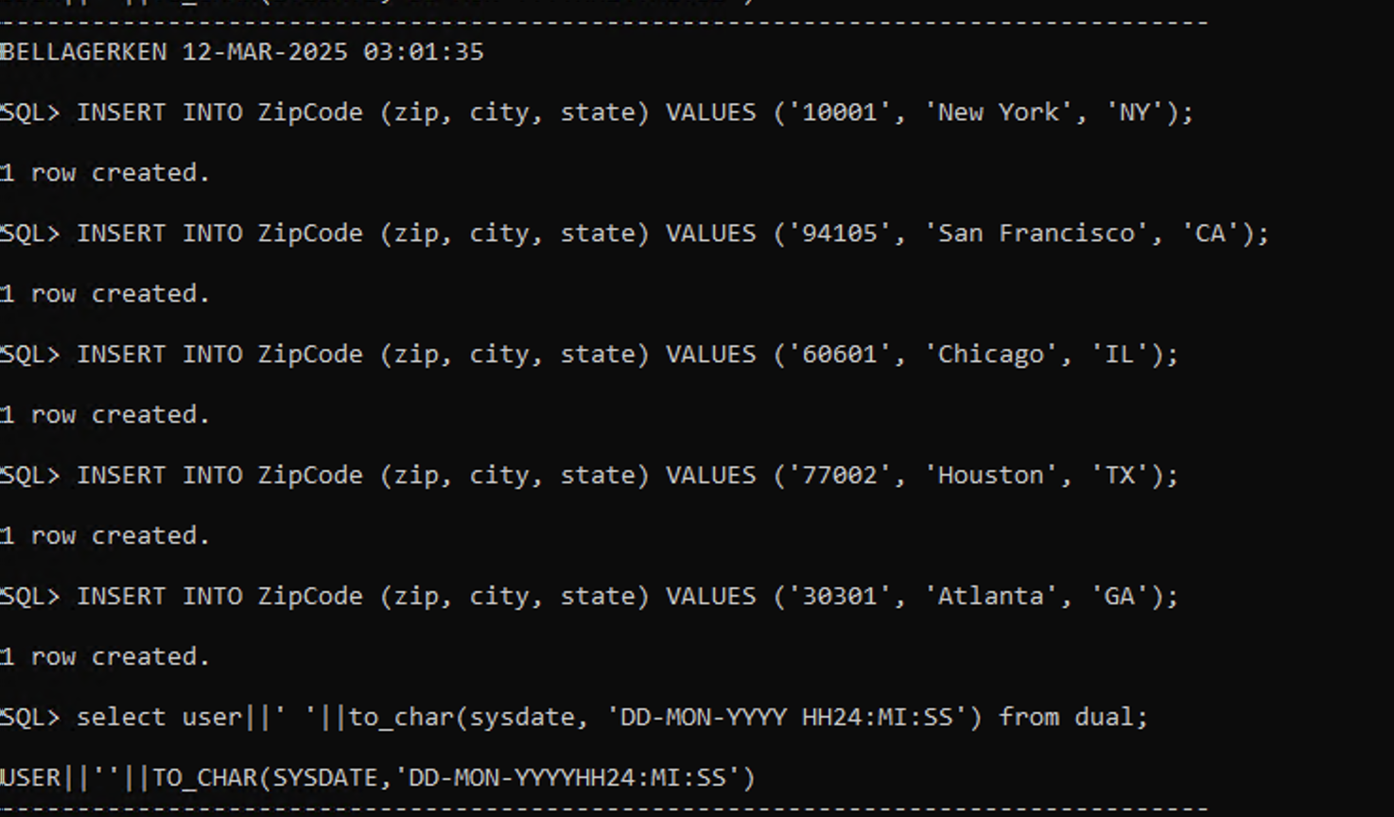

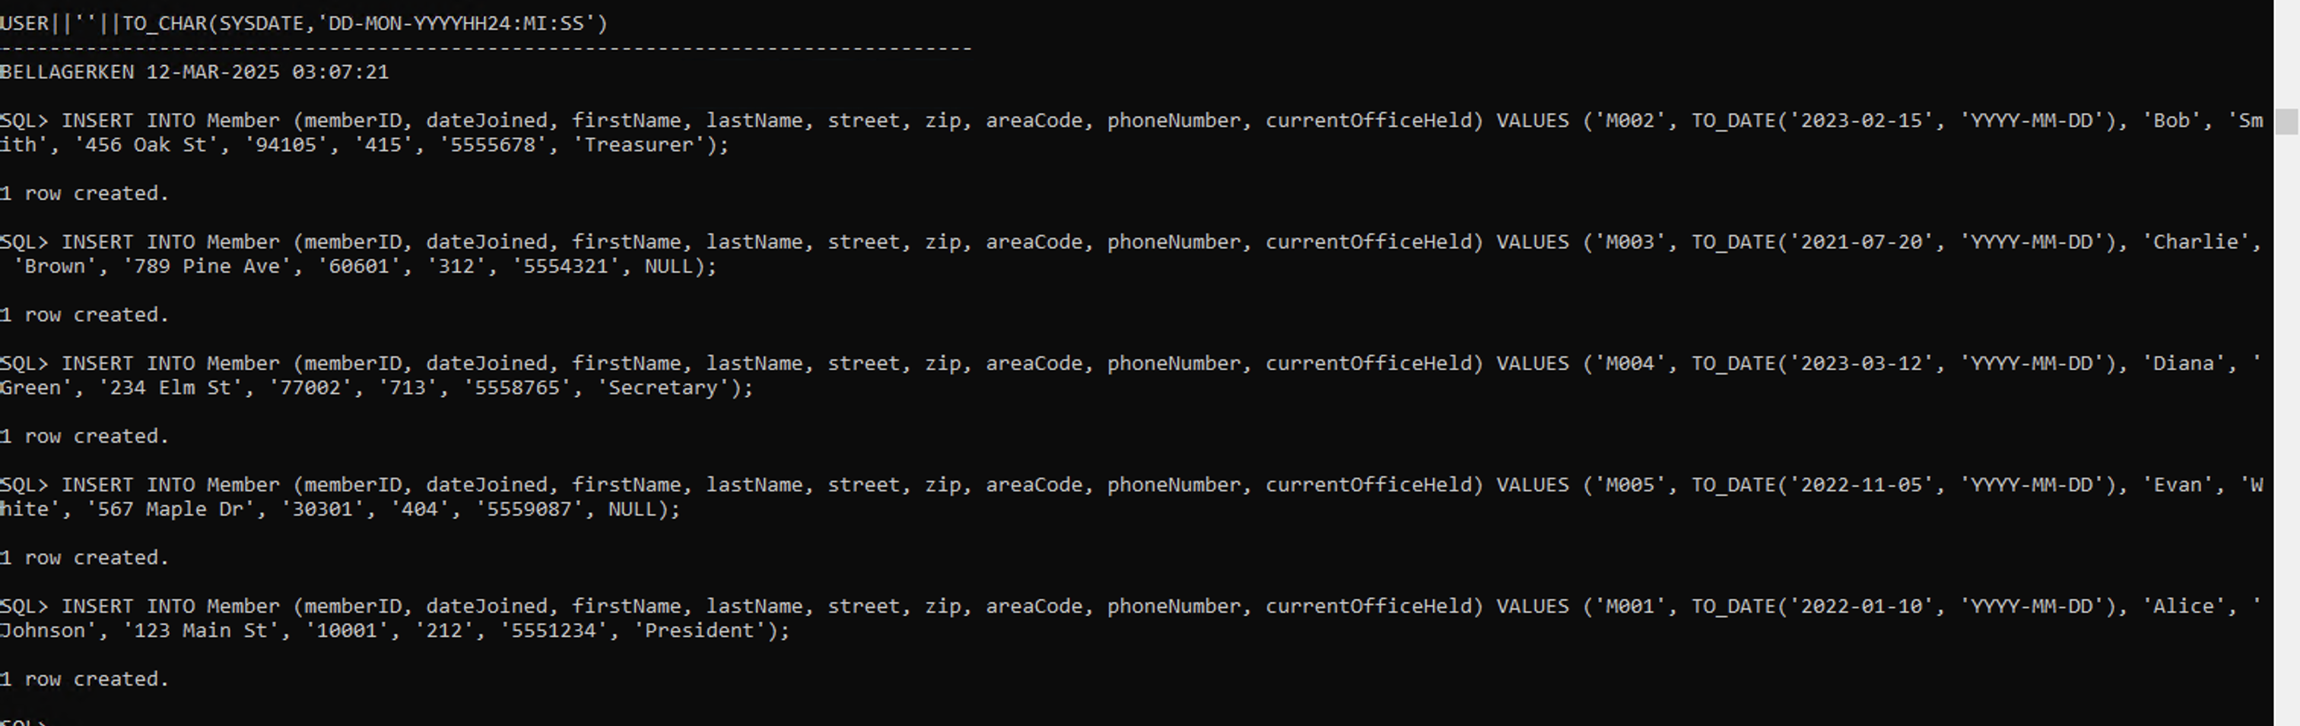

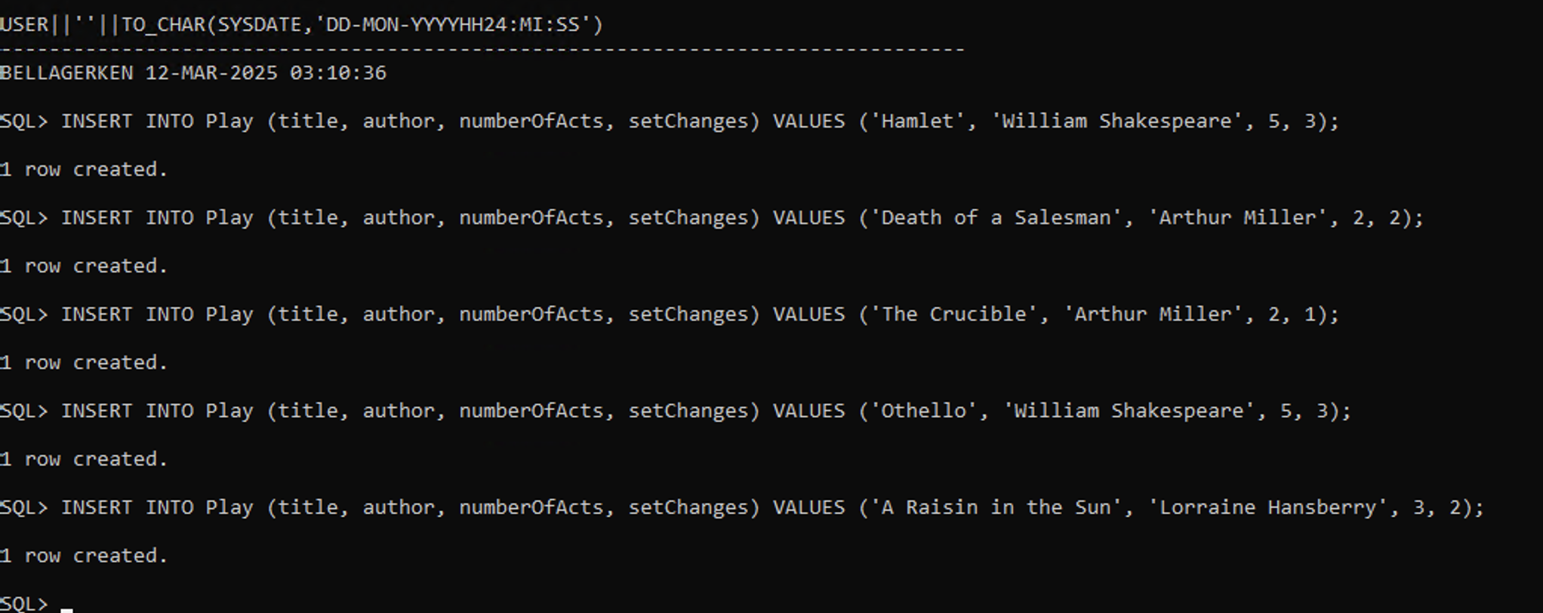

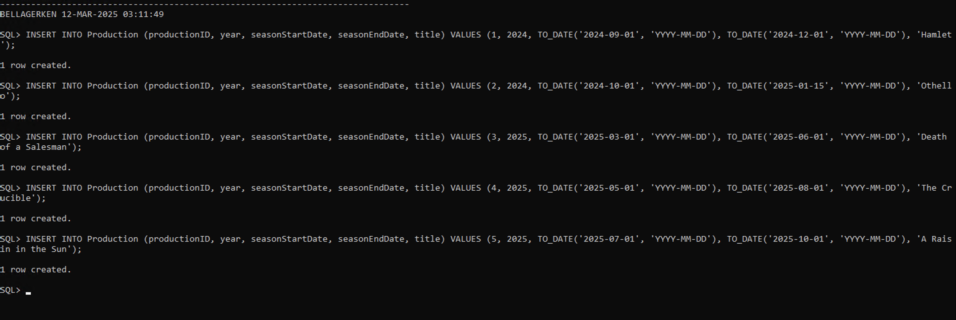

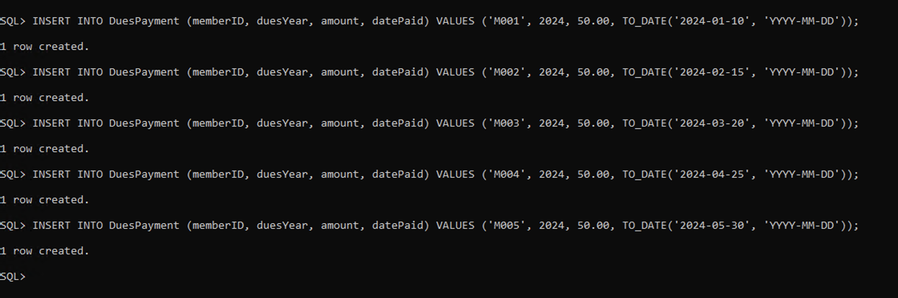

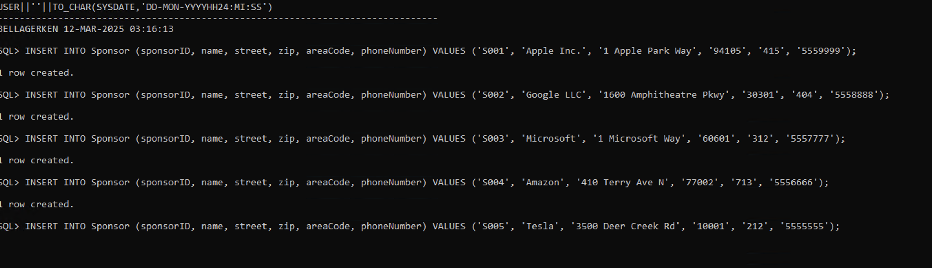

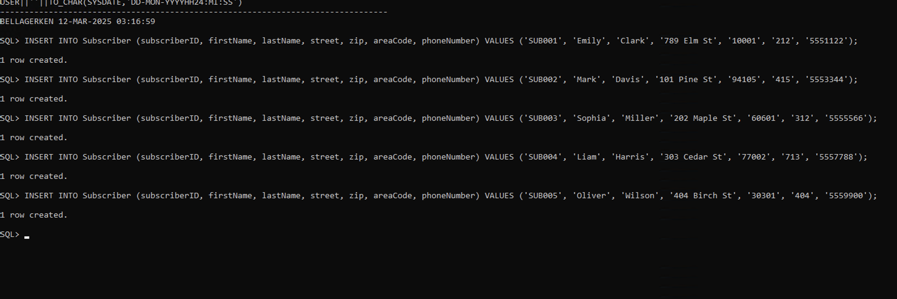

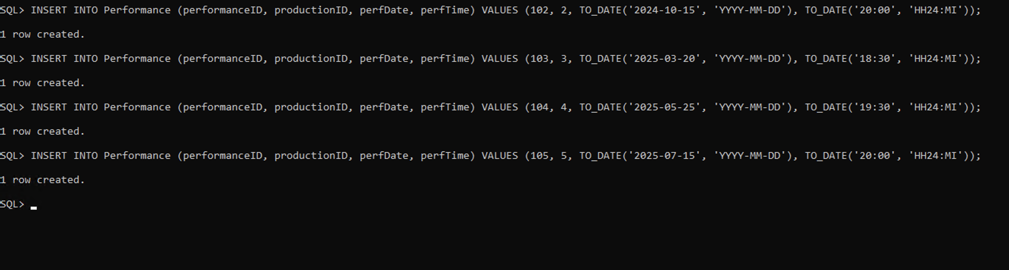

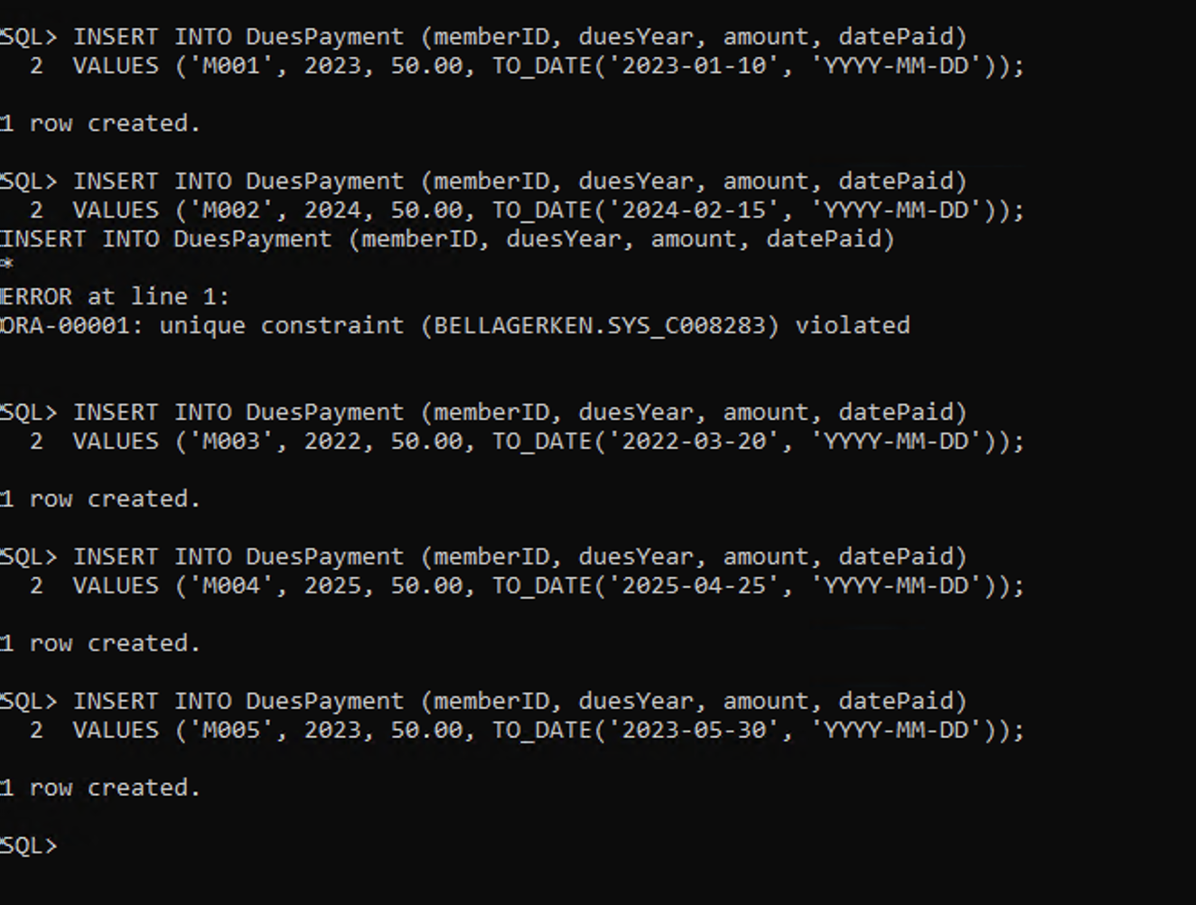

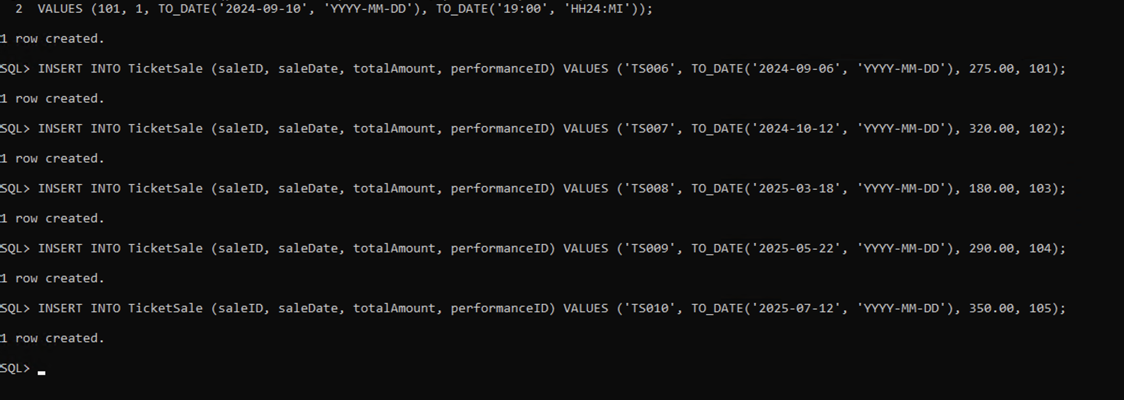

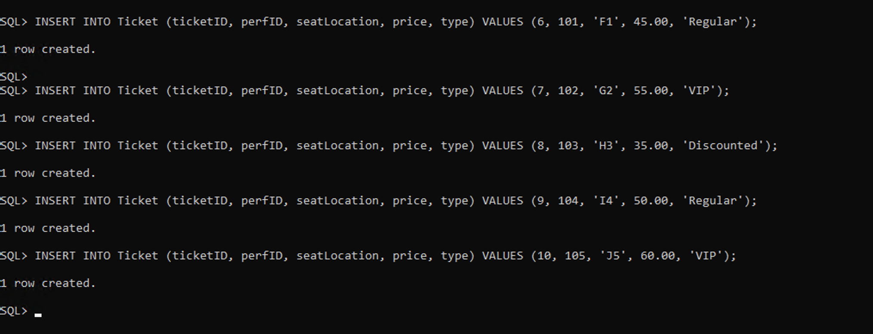

**Step 6.7 - Design five non-routine questions that will request information from the database for the team project. For each question, design a SQL statement that will be executed in the database to retrieve the requested information. Then execute each SQL statement in the database.** These five non-routine requests should be different from the ones you created in Chapter 5.

1. What is the average ticket price for each play?
   1. SELECT P.title, ROUND(AVG(T.price), 2) AS avg_ticket_price FROM Ticket T JOIN Performance PE ON T.perfID = PE.performanceID JOIN Production PR ON PE.productionID = PR.productionID JOIN Play P ON PR.title = P.title GROUP BY P.title ORDER BY avg_ticket_price DESC;
2. 10. Which city has the most members?
   1. SELECT Z.city, COUNT(M.memberID) AS total_members FROM Member M JOIN ZipCode Z ON M.zip = Z.zip GROUP BY Z.city ORDER BY total_members DESC FETCH FIRST 1 ROW ONLY;
3. 11. Which performance had the highest revenue from ticket sales?
   1. SELECT PE.performanceID, P.title, SUM(TS.totalAmount) AS total_revenue FROM Performance PE JOIN Production PR ON PE.productionID = PR.productionID JOIN Play P ON PR.title = P.title JOIN TicketSale TS ON PE.performanceID = TS.performanceID GROUP BY PE.performanceID, P.title ORDER BY total_revenue DESC FETCH FIRST 1 ROW ONLY;
4. Which performance had the highest number of tickets sold?
   1. SELECT PE.performanceID, P.title, COUNT(T.ticketID) AS total_tickets FROM Performance PE JOIN Production PR ON PE.productionID = PR.productionID JOIN Play P ON PR.title = P.title JOIN Ticket T ON PE.performanceID = T.perfID GROUP BY PE.performanceID, P.title ORDER BY total_tickets DESC FETCH FIRST 1 ROW ONLY;
5. Which sponsor contributed the highest total donation amount?
   1. SELECT D.sponsorID, S.name, SUM(D.donationValue) AS total_donated FROM Donation D JOIN Sponsor S ON D.sponsorID = S.sponsorID GROUP BY D.sponsorID, S.name ORDER BY total_donated DESC FETCH FIRST 1 ROW ONLY;

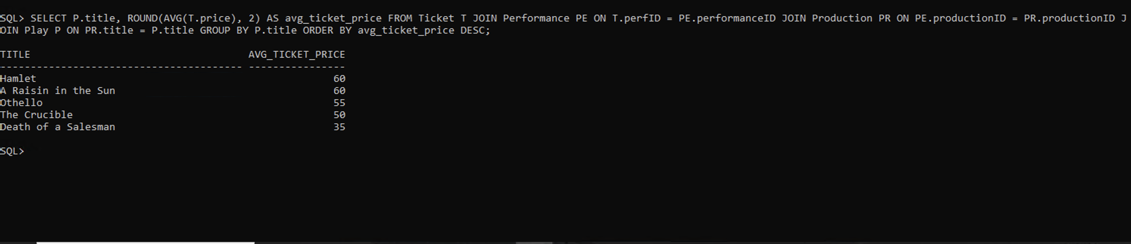

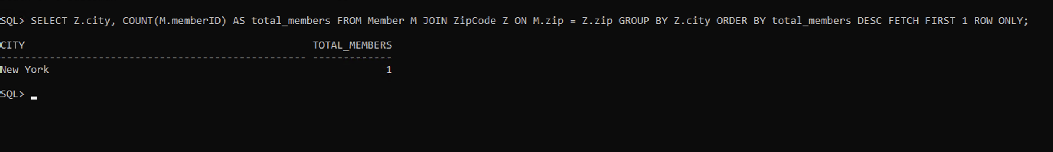

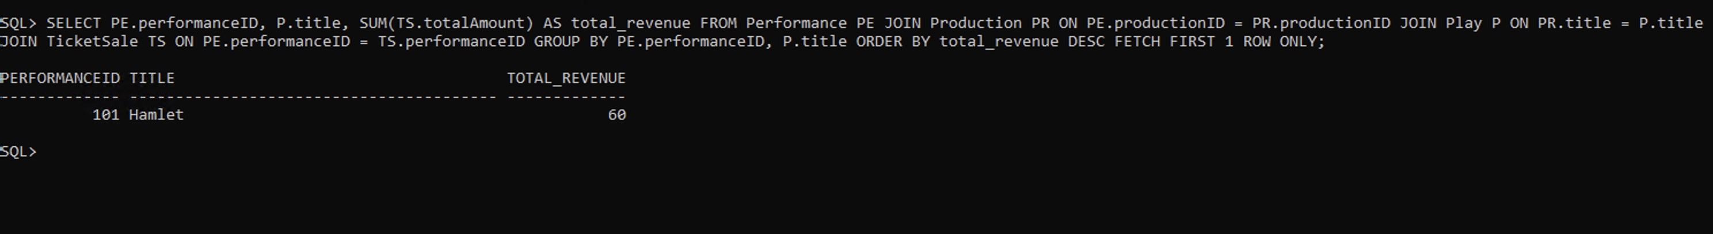

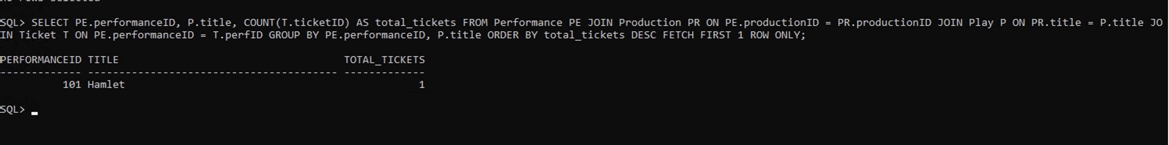

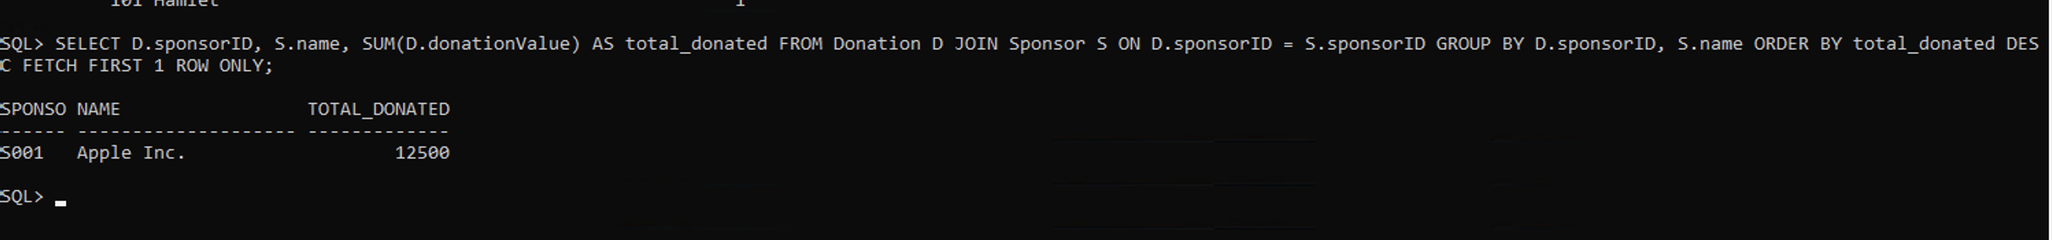

**Step 6.8 - Design one trigger for your project. Then create the trigger in the database. Then design and execute SQL statements to demonstrate that the trigger is working as expected.** Create a trigger that will update an attribute on one table whenever a row is updated on another table. To demonstrate that the trigger is working as expected, provide a single, continuous screenshot of the data before and after the trigger is executed. This trigger should be different from the one you created in Chapter 5.

CREATE OR REPLACE TRIGGER update_total_ticket_sale

AFTER UPDATE OF price ON Ticket

BEGIN

UPDATE TicketSale TS

SET TS.totalAmount = (SELECT COALESCE(SUM(T.price), 0)

FROM Ticket T

WHERE T.perfID = TS.performanceID);

END;

/

